DEV-02: Core ML Model Training

1. Overview
The core model is a linear regression that predicts a request's turnaround days from the 10 features defined in DEV-01. Linear regression was chosen because it is fast, needs little data, and every prediction can be explained to the registrar as "this office adds this many days" (DEV-03). The trained model is exported as a small JSON file that the Laravel application reads, so predictions run inside the existing system without a separate Python server.
Note on the data. The pilot has not yet collected enough completed requests to train a model. As allowed in Chapter 1, section 1.5, the training data is simulated from the system's own seeded credential types and signing workflows. The same scripts retrain the model on real requests once the pilot has enough (ml/export_dataset.sql exports them in the same columns).

2. Dataset Preparation
ml/train.py first validates every row. A row that breaks a rule is removed and written, with its reason, to ml/output/validation_report.csv.
Table 1. Validation rules applied before training
# | Rule | Rows rejected
1 | Schema: all 11 expected columns exist (otherwise the run stops) | 0
2 | Required fields are not empty | 12
3 | Missing target: the request has no ready date yet (still in progress) | 6
4 | Data type: copies and open_workload are numbers | 5
5 | Range: copies 1 to 10, workload not negative | 12
6 | Allowed values: student status is current or alumni | 4
7 | Consistency: the ready date is after the routing date | 5
8 | Duplicates: one row per reference number | 10
9 | Outliers: turnaround above the IQR fence is flagged but kept (63 rows), because long holds are real events the model must learn from | 0

Feature engineering then turns each clean row into model inputs: the workflow text (for example LIB>FIN>COLLEGE>REG) becomes the four office flags, the student status becomes is_alumni, and the routing month becomes is_peak_month. The target is computed from the two timestamps.
A "number of signing offices" feature was tried and removed. It always equals the four office flags plus the Registrar step, so it made the features perfectly collinear and split their effects unpredictably.

3. Train/Test Split
The 1956 clean rows are split at random into 80% training (1564 rows) and 20% testing (392 rows) with a fixed seed (random_state=42) so the result is reproducible. The test set is only used once, for the final scores in section 5.

4. Model and Hyperparameter Configuration
Table 2. Model configuration
Setting | Value
Library | scikit-learn 1.6
Pipeline | StandardScaler then the regressor (scaling puts all features on the same scale for regularisation)
Candidate 1 | Ordinary least squares (LinearRegression)
Candidate 2 | Ridge regression (Ridge), linear regression with an L2 penalty on large weights
Hyperparameter searched | Ridge alpha in {0.01, 0.1, 1, 3, 10, 30, 100, 300, 1000}
Validation | 5-fold cross-validation on the training set only, scored by MAE
Selection rule | Lowest cross-validation MAE (never the test set)

Table 3. Cross-validation results (training set)
Candidate | CV MAE (days) | Notes
OLS | 3.022 | CV R² 0.495
Ridge, alpha = 30 | 3.014 | Best alpha; chosen

Ridge with alpha = 30 was chosen. The difference from OLS is small, which is expected: the features are few and not strongly redundant once the collinear feature was removed. The penalty mainly steadies the office flags, which tend to appear together in the same credential types.

5. Model Evaluation
Table 4. Test-set results (392 requests the model never saw)
Model | MAE (days) | RMSE (days) | R²
Baseline: always the average (DEV-01) | 4.405 | 5.857 | 0.000
Linear regression, OLS | 3.065 | 4.300 | 0.461
Linear regression, Ridge (chosen) | 3.065 | 4.301 | 0.461

The model cuts the average error from 4.4 to 3.1 days (30% lower) and explains 46% of the variation in turnaround, against 0% for the baseline.
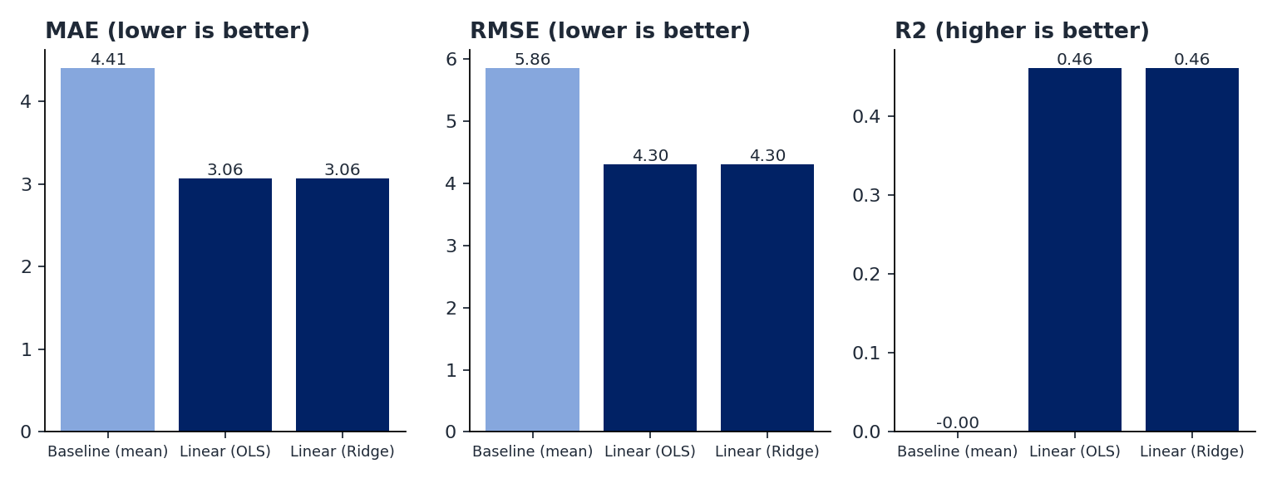
Figure 1. Baseline versus linear regression on the test set

5.1 Deadline-breach early warning
The model's purpose is the at-risk flag, so it was also scored as a classifier: a request is flagged when its predicted ready date is after its due date, and the flag is compared with whether it really finished late.
Table 5. At-risk flag on the test set (127 requests really finished late)
Model | Flagged | Precision | Recall | F1
Baseline | 192 | 0.365 | 0.551 | 0.439
Linear regression | 116 | 0.560 | 0.512 | 0.535

The model raises far fewer false alarms (precision 0.56 against 0.37) while catching about the same share of late requests, so the registrar can trust a flag more.

5.2 Errors
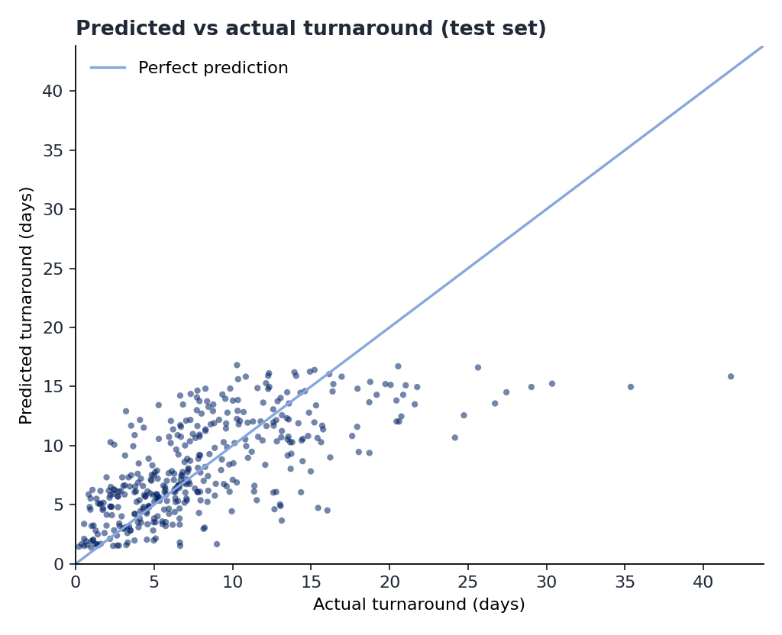
Figure 2. Predicted versus actual turnaround (test set)
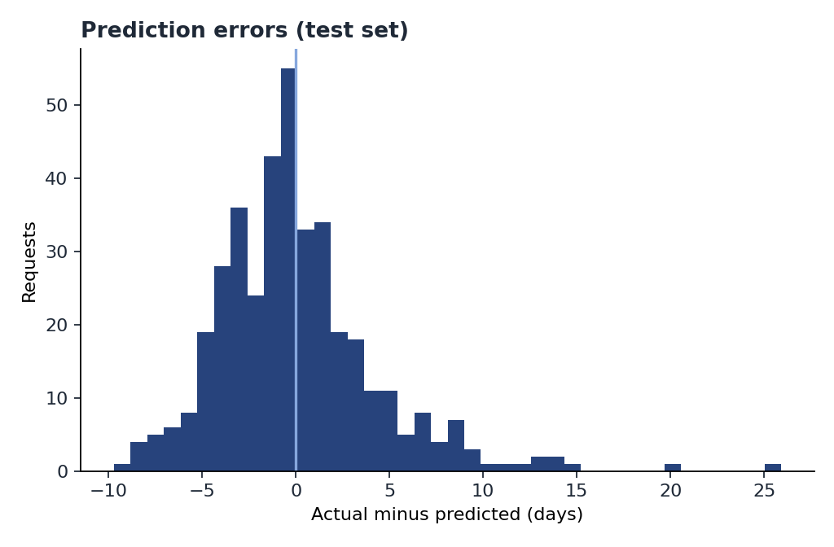
Figure 3. Distribution of prediction errors (test set)
Most requests sit close to the diagonal. The clear weakness is on the right of Figure 2: requests that took 20 days or more were predicted at about 12 to 16 days. Those are requests with one or more long holds, which are random events the routing-time features cannot foresee. This is the main limitation to state when presenting the model.

6. Final Model and Output
train.py folds the scaler into the weights and writes the final model to resources/ml/turnaround-model.json, so a prediction is the intercept plus each feature times its weight.
Table 6. Final weights (days added per unit of each feature)
Feature | Weight
Intercept | 0.049
Processing days (processing_days) | 0.056
Paid credential (requires_payment) | 0.138
Library step (has_library) | 2.137
Cashier step (has_finance) | 2.566
Student Affairs step (has_student_affairs) | 1.674
College step (has_college) | 3.538
Copies (copies) | 0.383
Alumni requester (is_alumni) | 1.228
Open requests at routing (open_workload) | 0.071
Peak month (is_peak_month) | 2.000

6.1 Example prediction
A Transcript of Records (Library, Cashier, college and Registrar), 2 copies, requested by an alumnus, routed on a normal month with 20 requests already in progress:
0.049 + 10 x 0.056 + 1 x 0.138 + 1 x 2.137 + 1 x 2.566 + 1 x 3.538
+ 2 x 0.383 + 1 x 1.228 + 20 x 0.071 = 12.4 days
Routed on a Monday, the TOR is due in 14 calendar days (10 working days), so the request is on track. Routed late on a Saturday, its 10 working days end 12 calendar days later, so the same 12.4 days makes it at risk. This is the output the API (DEV-04) and the dashboard (DEV-05) show.

7. Limitations
- The model is trained on simulated data, so it learns the simulation's assumptions. Its real value is measured only after retraining on pilot requests.
- Long holds are random and are under-predicted (section 5.2). A later version could add live features such as "currently on hold" for requests already in progress.
- An R² of 0.46 means more than half of the variation is still unexplained, mostly by holds. The model is an early-warning aid for the registrar, not a promise to the student.

